**Task 14**

**Computer Network Lab**



**Submitted to Sir Rasikh Ali  
Submitted by Muhammad Ibtisam**

**Roll #: SU92-BSSEM-F22-288  
Section: SE-5B**

**Submitted on Dec 10th, 2024**

**DEPARTMENT OF SOFTWARE ENGINEERING  
SUPERIOR UNIVERSITY, LAHORE**

# **Project Report**

# **Corporate Office Network:**

**Pictures of Network:**

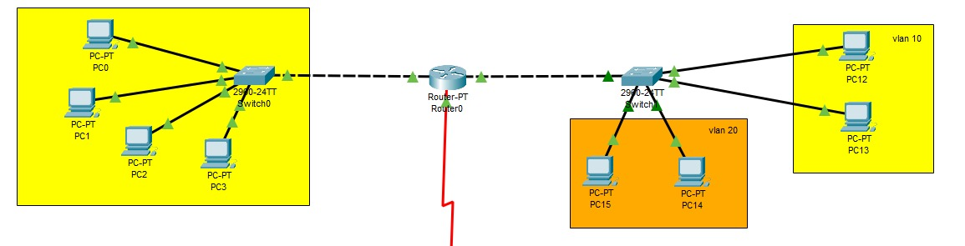

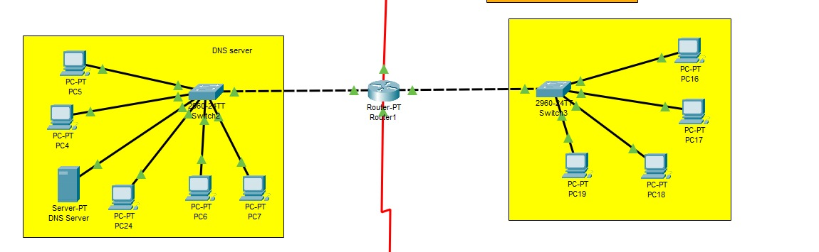

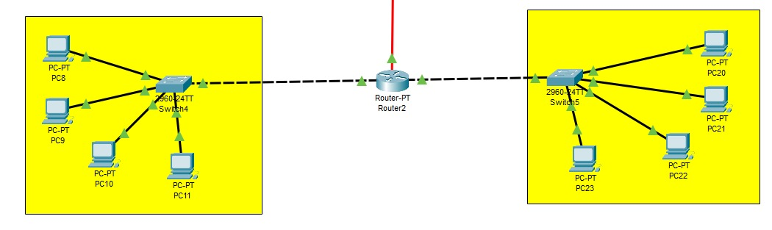

**DNS Server:**

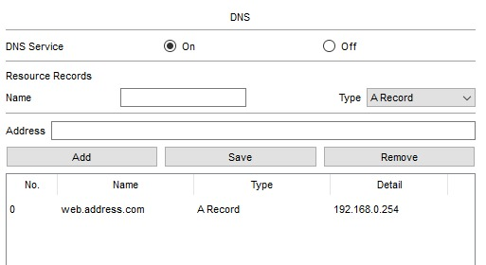

**DNS Server Connectivity:**

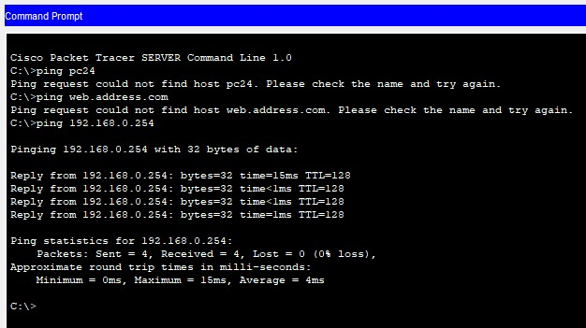

**Pc to Router Connectivity:**

**Floor 1:**

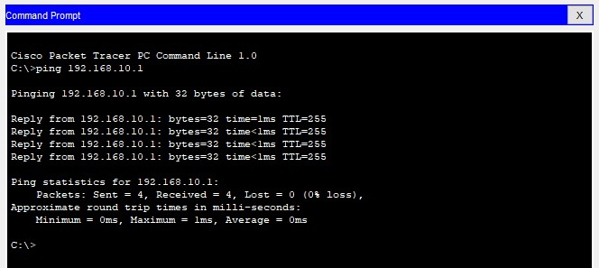

**Floor 2:**

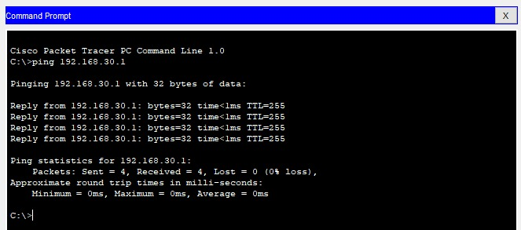

**Pc to Pc Connectivity:**

**Floor 1:**

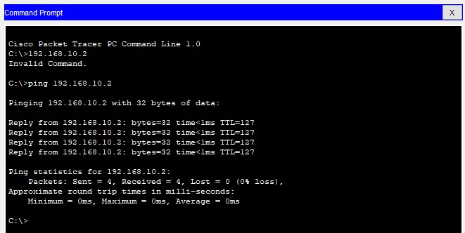

**Floor 2:**

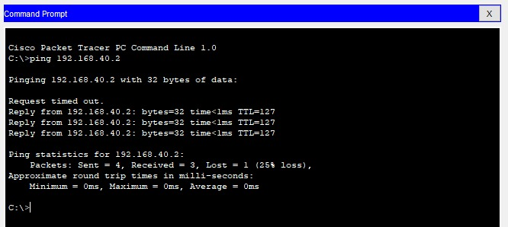

**IP’s Used in Routers:**

**Router 0:**

Fa0/0: 192.168.10.1

Fa0/1: 192.168.20.1

Serial2/0: 10.0.0.1

**Router 1:**

Fa0/0: 192.168.30.1

Fa0/1: 192.168.40.1

Serial2/0: 10.0.0.2

Serial3/0: 11.0.0.1

**Router 2:**

Fa0/0: 192.168.50.1

Fa0/1: 192.168.60.1

Serial3/0: 11.0.0.2

**Routing Commands:**

**Commands Used in Routers:**

**Router0:**

Router(config)#router rip

Router(config-router)#network 192.168.10.0

Router(config-router)#network 10.0.0.0

**Router1:**

Router(config)#router rip

Router(config-router)#network 192.168.20.0

Router(config-router)#network 10.0.0.0

Router(config-router)#network 11.0.0.0

**Router2:**

Router(config)#router rip

Router(config-router)#network 192.168.30.0

Router(config-router)#network 11.0.0.0

**Router DHCP Configuration:**

interface Fa0/0

ip address 192.168.10.1 255.255.255.0

ip dhcp pool POOL1

network 192.168.10.0 255.255.255.0

default-router 192.168.10.1

interface Fa0/1

ip address 192.168.20.1 255.255.255.0

ip dhcp pool POOL2

network 192.168.20.0 255.255.255.0

default-router 192.168.20.1

**Router 1:**

interface Fa0/0

ip address 192.168.30.1 255.255.255.0

ip dhcp pool POOL3

network 192.168.30.0 255.255.255.0

default-router 192.168.30.1

interface Fa0/1

ip address 192.168.40.1 255.255.255.0

ip dhcp pool POOL4

network 192.168.40.0 255.255.255.0

default-router 192.168.40.1

**Router 2:**

interface Fa0/0

ip address 192.168.50.1 255.255.255.0

ip dhcp pool POOL5

network 192.168.50.0 255.255.255.0

default-router 192.168.50.1

interface Fa0/1

ip address 192.168.60.1 255.255.255.0

ip dhcp pool POOL6

network 192.168.60.0 255.255.255.0

default-router 192.168.60.1

**VLAN Configuration:**

In Switch:

Switch#config terminal

Switch(config)#vlan 10

Switch(config-vlan)#name VLAN_10

Switch(config-vlan)#vlan 20

Switch(config-vlan)#name VLAN_20

Switch>enable

Switch#config terminal

Switch(config)#int fa0/1

Switch(config-if)#switchport mode access

Switch(config-if)#switchport access vlan 10

Switch(config-if)#int fa0/2

Switch(config-if)#switchport mode access

Switch(config-if)#switchport access vlan 10

Switch(config-if)#int fa0/3

Switch(config-if)#switchport mode access

Switch(config-if)#switchport access vlan 20

Switch(config-if)#int fa0/4

Switch(config-if)#switchport mode access

Switch(config-if)#switchport access vlan 20

Switch(config-if)#int range fa0/1-4

Switch(config-if-range)#switchport mode access

Switch(config)#int gig 0/2

Switch(config-if)#switchport mode trunk